# **Week-2 Compiler Design Lab**

G.V.S.Sridhar

AP20110010615

CSE-I

In the given symbol Table program, I took an expression by this I define the tokens in the given one

And every token is compared and classified as the following way given in the example below

Ex: I took ‘a’ is identifier, any digit as constant, = as operator and <= and many as relational operator

I took the expression and declared character array which I defined size of 50 and I took integer data type

Output: -

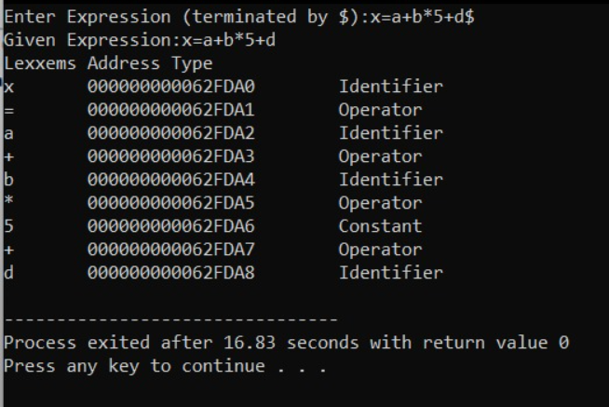

àTherefore they are divided into address and type of the given ones.